Comprehensive Study of Light and Heavy-weight Models on Diverse Datasets with and without Noise
Braj Raj Nagar (2022AIB2682) Sangam Kumar (2022AIB2671)
Abstract:
This project evaluates the performance of light-weight models like ShuffleNet and MobileNet, and a heavy-weight model like ViT on UC Merced, Optimal, and Aerial datasets. The models were tested under different levels of noise, and the light-weight models was found to be more robust and resilient to noise than the ViT model. These findings highlight the importance of selecting the most suitable model based on specific requirements and application needs.

Introduction:
- Models Used
- 1. MobileNET V2(Light-weight)
- 2. ShuffleNET V2(Light-weight)
- 3. Vision Transformer(ViT)(Heavy-weight)

- Dataset Used
- UC Merced dataset: This dataset contains 21 classes of land-use patterns in the central California area, including airports, residential areas, farmland, and more. It consists of 2100 high-resolution aerial images.
- AID dataset: This dataset contains satellite images of 30 classes of land-use patterns in developing countries, including urban areas, forests, and farmland. Consist of 10,000 images of medium spatial resolution.
- Optimal 31 dataset: This dataset contains satellite images of agricultural land in multiple countries, including Brazil, South Africa, and the United States. Consist of 31 classes of high resolution images.
Methodology:
The methodology involved training and evaluating light-weight models (ShuffleNet and MobileNet) and a heavy-weight model (ViT) on three different datasets (UC Merced, Optimal, and Aerial). The models were trained and tested using standard evaluation metrics, and noise was added to the datasets using standard data augmentation techniques. The performance of the models was compared under different levels of noise to determine their resilience to noise.

1. Comparison of all three models on different datasets
 | AID | Optimal-31 | UCMerced
MobileNET V2 | 100 | 99.2839 | 100
ShuffleNET V2 | 97.650 | 96.4844 | 99.4213
ViT | 100 | 100 | 100
Table 1.1 Training Performance (Accuracy in %)

 | AID | Optimal-31 | UCMerced
MobileNET V2 | 95.9961 | 91.0256 | 95.6845
ShuffleNET V2 | 92.0898 | 86.2981 | 93.2292
ViT | 95.6543 | 93.6899 | 96.9742
Table 1.2 Test Performance (Accuracy in %)
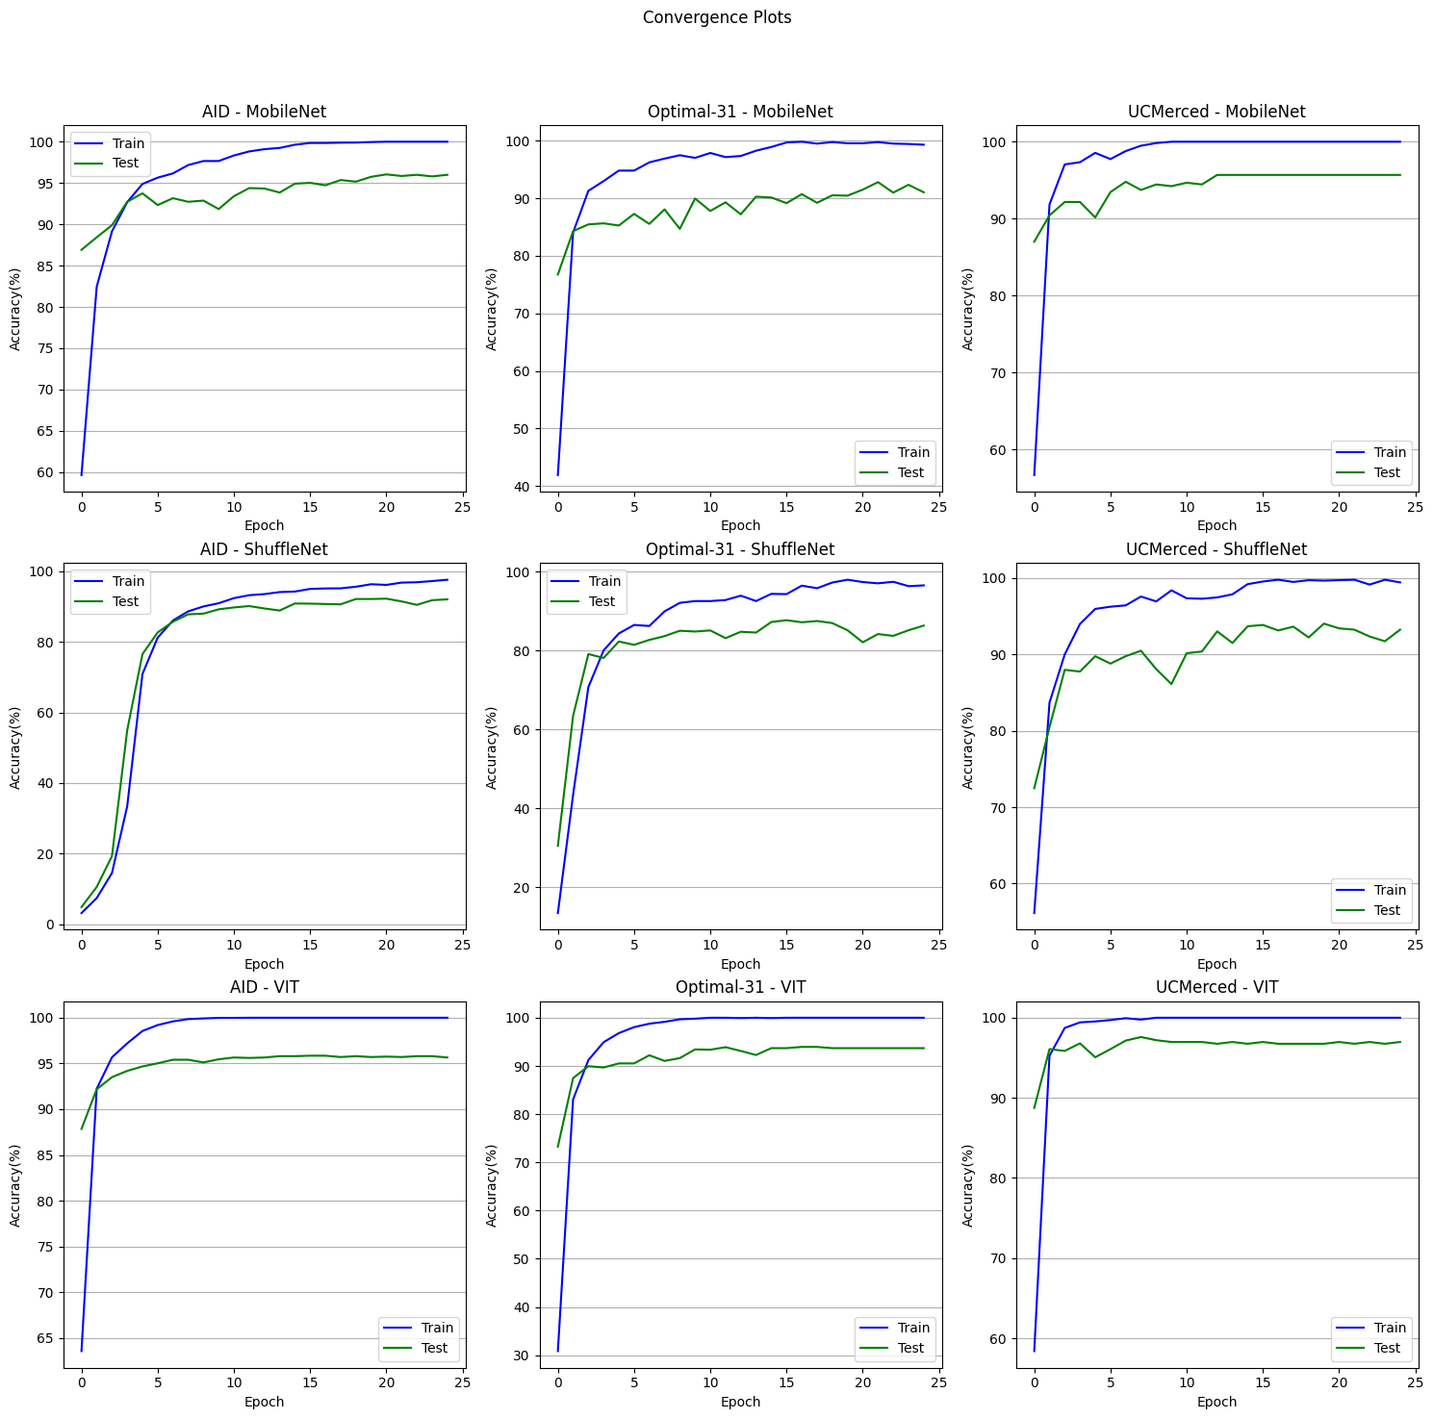
Fig 1 Comparison between all models for different dataset.
So it can clearly be observed that light weight model gives almost as good accuracies as heavy weight models on aerial images. Because light weight models are computationally less expensive it can be a good alternative for heavy weight models.

2. Light weight model (mobileNet) and ViT performance on noisy data
mobileNet performance on noisy data
 | 0% Noise | 10% Noise | 20% Noise | 40% Noise
UC Merced | 100 | 88.369 | 86.365 | 68.396
Optimal 31 | 100 | 93.573 | 83.593 | 75.692
Table 2.1 Training Performance with Noisy Dataset (Accuracy in %)

 | 0% Noise | 10% Noise | 20% Noise | 40% Noise
UC Merced | 79.57 | 73.102 | 66.796 | 49.5536
Optimal 31 | 86.216 | 77.846 | 66.183 | 50.558
Table 2.2 Test Performance With Noisy Dataset (Accuracy in%)
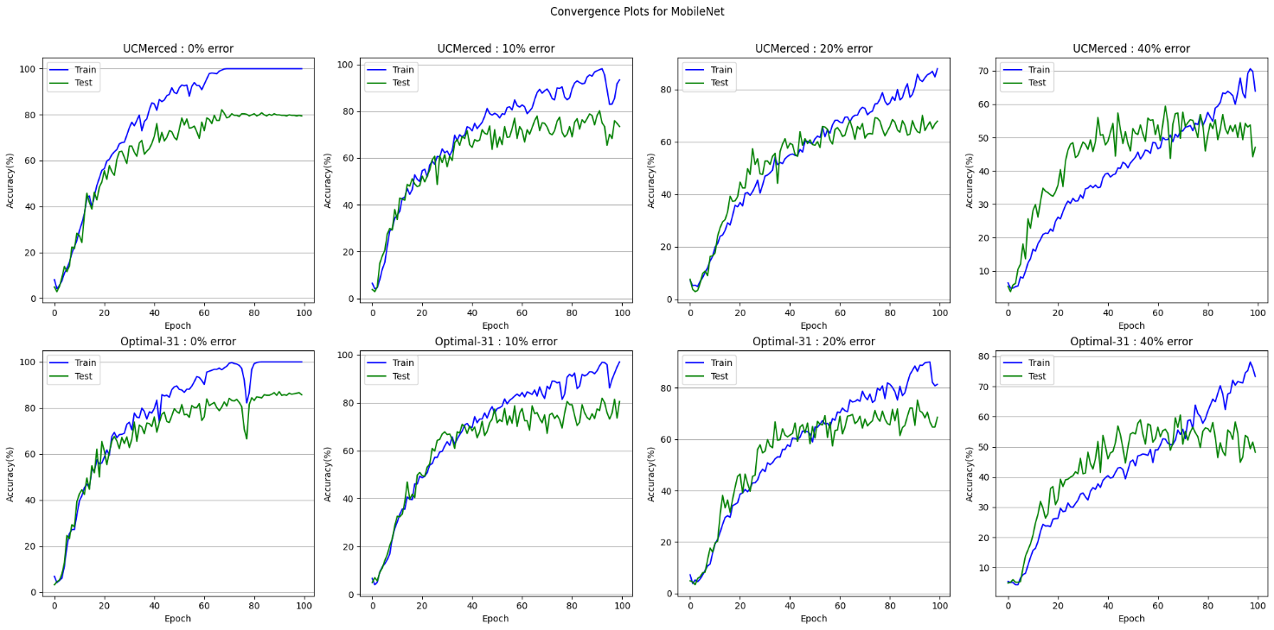
Fig 2.1 Comparison of mobileNet performance n UCMerced and Optimal-31 datasets for different level of Noise
ViT performance on noisy data
 | 0% Noise | 10% Noise | 20% Noise | 40% Noise
UC Merced | 100 | 99.6167 | 99.6167 | 98.9387
Optimal 31 | 99.867 | 99.5346 | 99.2021 | 98.0884
Table 2.3 Train Performance with Noise Dataset (Accuracy in %)

 | 0% Noise | 10% Noise | 20% Noise | 40% Noise
UC Merced | 80.7478 | 71.0938 | 57.9241 | 48.7723
Optimal 31 | 64.6094 | 57.2656 | 48.7109 | 36.7318
Table 2.4 Test Performance with Noise Dataset (Accuracy in %)
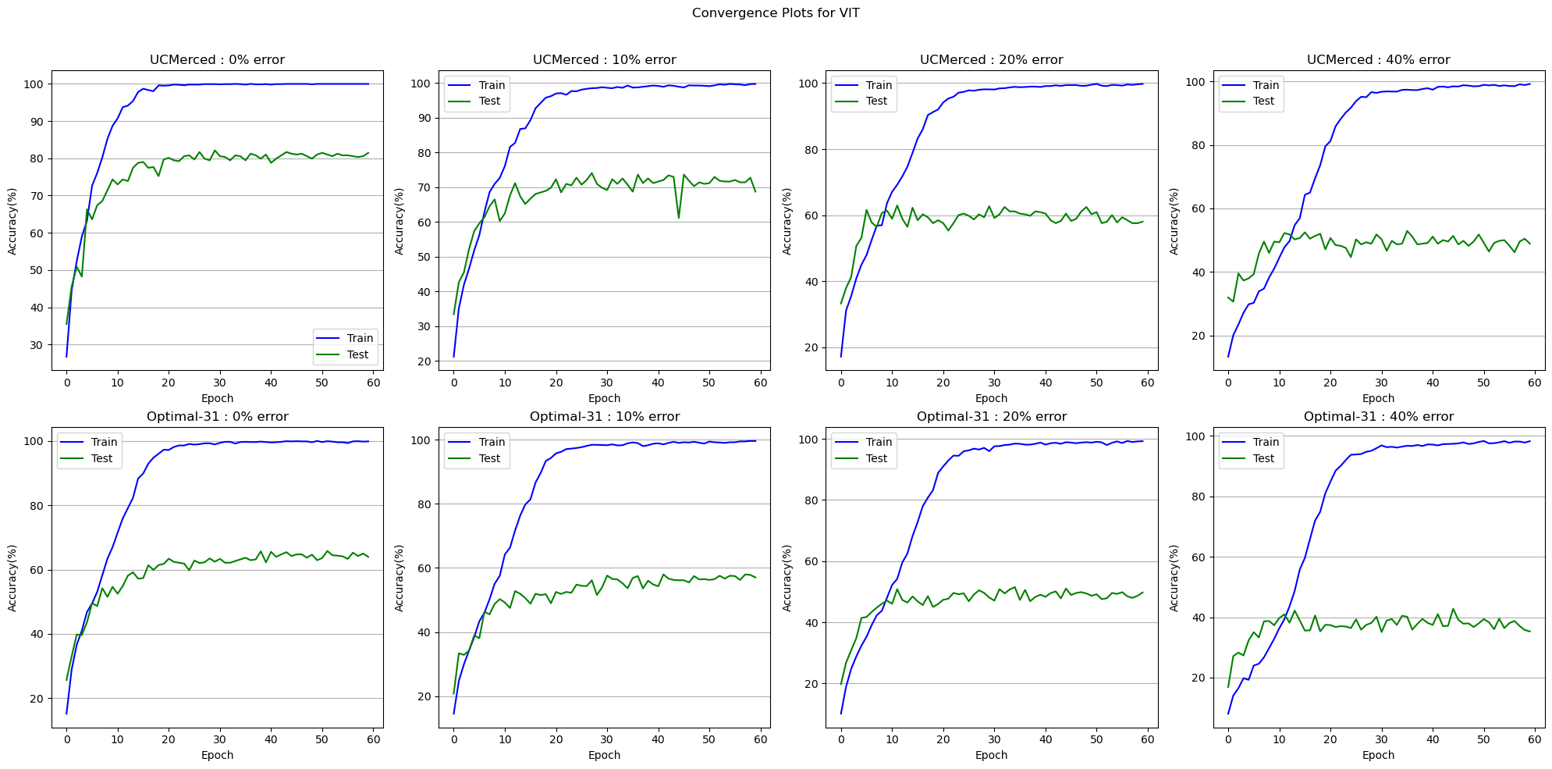
Fig 2.2 Comparison of UCMerced and Optimal-31 datasets for different Noise with ViT
Comparing the performance of mobileNet and ViT on noisy datasets it can be seen clearly that ViT (heavy weight model) are more prone to over fit the noise data. Obliviously because heavy weight models have large number of parameters so it tries to fit every noisy training data point as good as it can which eventually leads to the poor performance on test dataset. Whereas light weight model have less number of parameters and makes them more robust to the noisy data and give comparatively better performance than heavy weight models.

3. Pre-trained ViT performance on noisy data while keeping all the layers freezed except the last fully connected layer during training
 | 0% error | 10% error | 20% error | 40% error
UCMerced | 99.9116 | 92.3791 | 85.8638 | 74.3956
Optimal-31 | 99.4348 | 92.4368 | 85.8378 | 76.5293
Table 3.1 Training Performance with Noisy Dataset (Accuracy in %)

 | 0% error | 10% error | 20% error | 40% error
UCMerced | 95.9821 | 93.5826 | 91.5179 | 77.2879
Optimal-31 | 86.6406 | 81.1979 | 81.2891 | 69.9349
Table 3.2 Test Performance with Noisy Dataset (Accuracy in %)
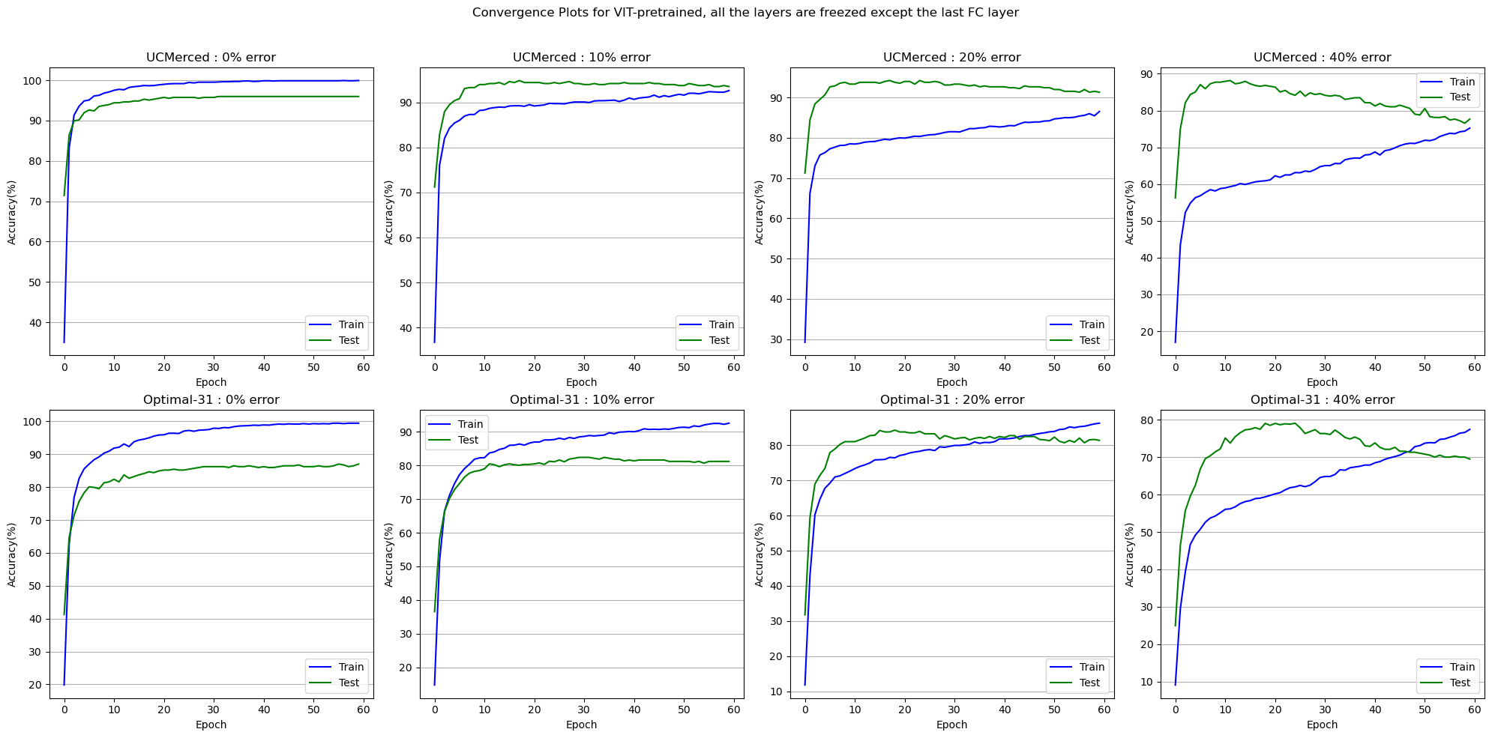
Fig 3 Comparison of UCMerced and Optimal-31 datasets for different Noise with ViT while keeping all the layers freezed except the last fully connected layer
As we used pertained model for noisy train dataset at the beginning training accuracy is less and test accuracies are more than train accuracies in some case. But as the training progresses train accuracies improves but because only last fully connected layer’s parameters gets updated as the the train accuracies start improving test accuracies start falling. Which may not be because model is overfitting because test accuracies start falling long before model reach saturation. So the reason of test accuracy getting worse could be that all the parameters except last layer are freezed and those pre-trained parameters didn’t get fine-tuned for our dataset.
Conclusion
We found that heavy model is more affected by the noise as comparison to light model. This happens since heavy model are more prone to over fit due large number of parameter it over fits the train data very quickly whereas light models doesn’t over fit because and gives better accuracies compare to heavy model. Light weight models are also time and storage efficient beacse of less no. of parameters. And In the experiment we found out that fine-tuning of all the parameters is necessary to adapt the model for new unseen dataset.
Future Work
- Investigate the use of other noise types and levels to further evaluate the resilience of different models and explore the impact of noise on model performance.
- Investigate the impact of different levels of noise on different classes or categories of images to identify which types of images are more affected by noise and which models are more resilient to these types of images.

